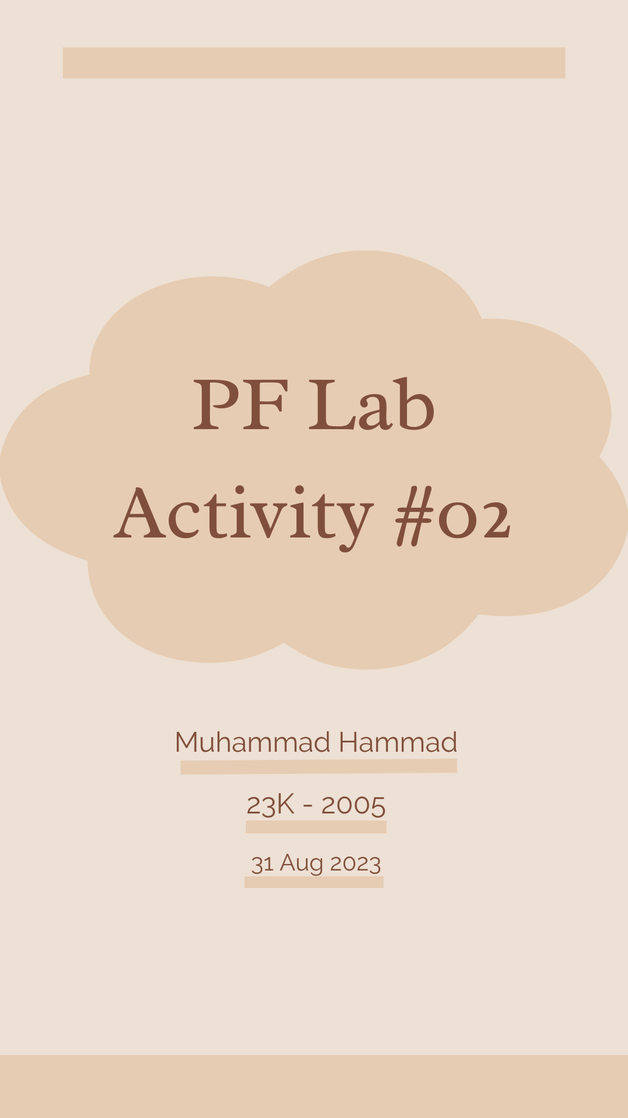

**Question #01**

**Input, Processing and Output Chart**

|  |  |  |
| --- | --- | --- |
| Input | Processing | Output |
| Number | Take modulus of the number | Declare the number either even or odd |

**Scratch Design and Structure**

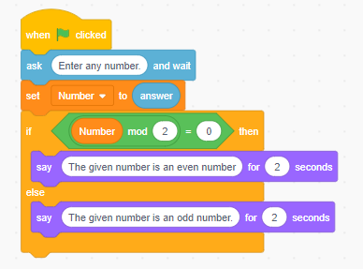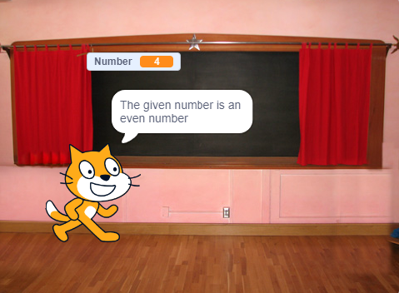

**Question #02**

**Input, Processing and Output Chart**

|  |  |  |
| --- | --- | --- |
| Input | Processing | Output |
| Number (Start from 1) | Square the first number Increment in the first number by 1 Square the new number Increment in the number that was squared lastly  Repeat | Series |

**Scratch Design and Structure**

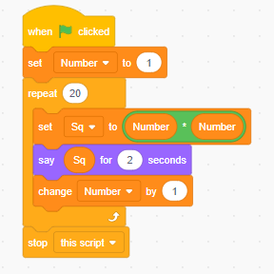

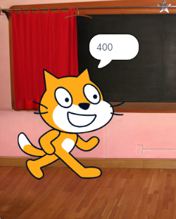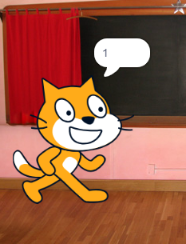

**Question #03**

**Input, Processing and Output Chart**

|  |  |  |
| --- | --- | --- |
| Input | Processing | Output |
| Normal charges (Given)  Duration of stay (Input from user) | Take duration input Calculate normal, double and triple charges Use if else condition | Total charges according to the duration of stay |

**Scratch Design and Structure**

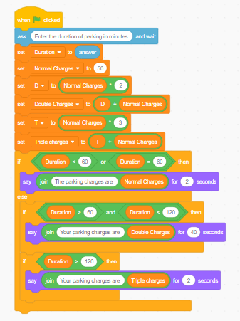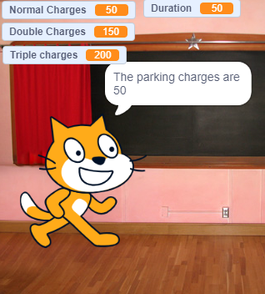

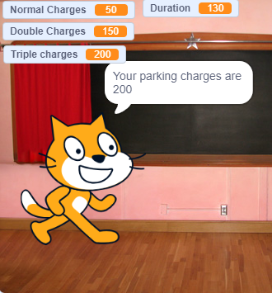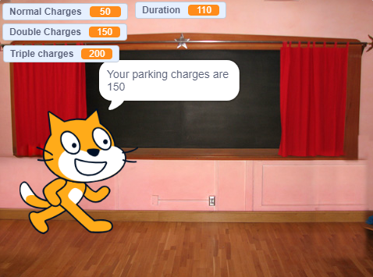**Question #04**

**Input, Processing and Output Chart**

|  |  |  |
| --- | --- | --- |
| Input | Processing | Output |
| Obtained marks in the four subjects | Calculate obtained marks, total marks and percentage Apply if else condition Say | Grade |

**Scratch Design and Structure**

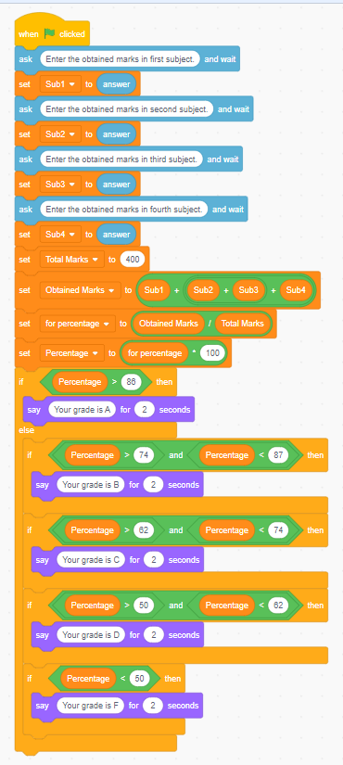

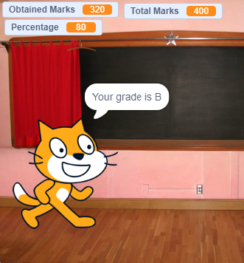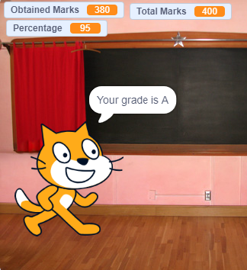

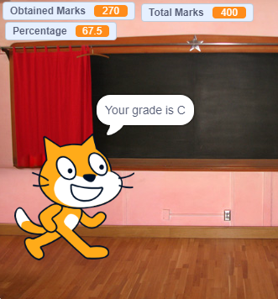

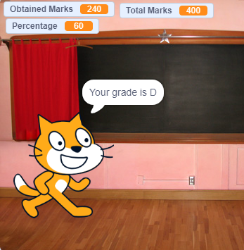

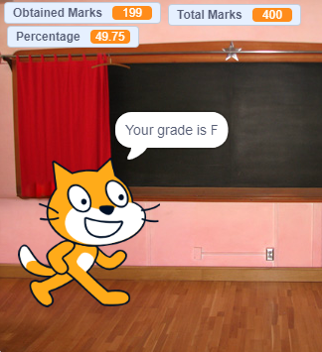

**Question #05**

**Input, Processing and Output Chart**

|  |  |  |
| --- | --- | --- |
| Input | Processing | Output |
| Click the flag | Print the value of X  Increment in the value of X by 1  Say Repeat 10 times | Final value of X after ten increments |

**Scratch Design and Structure**

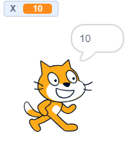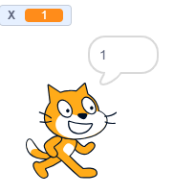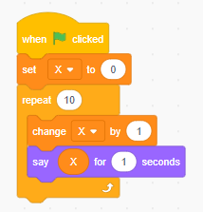

**Question #06**

**Input, Processing and Output Chart**

|  |  |  |
| --- | --- | --- |
| Input | Processing | Output |
| Temperature | Check whether the temperature is below, equal or greater than 15 and 40. Apply forever loop  Apply if else condition | Sense of temperature (Low, Medium, High or show Error) |

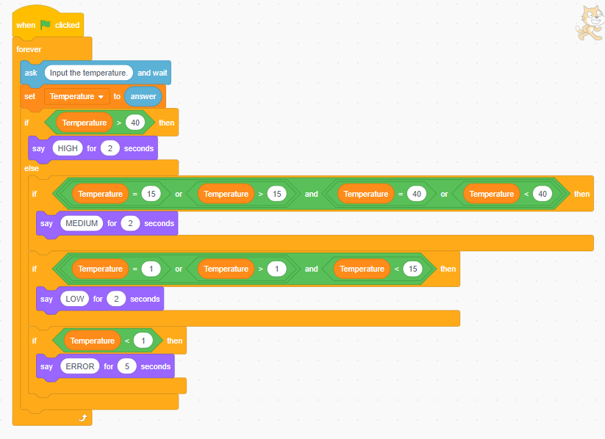

**Scratch Design and Structure**

